Code 1: Calculation of the Area of a Circle

Objective:
The aim of the lab is to create a simple Java program capable of calculating and displaying the area of a circle according to a given radius. The program will be based on the application of basic mathematical operations, input, and output functions.

Components Used:
1. Java program compiler : To write, compile, and run the Java program.
2. Variables:
Radius: a double variable to store the radius of the circle.
Area: a double variable to store the computed area.
3. Mathematical formula: To compute the area of the circle we use the formula:
Area =Pi or 3.1416*Radius*Radius
4. Libraries:
No external libraries; the code relies solely on standard Java packages.

Theory:
One of the basic calculations in geometry involves finding the area of a circle. This is the region enclosed by a circle and can be mathematically expressed as:
Area = π × Radius x Radius
Where:
(Pi) ≈ 3.1416.
Radius is the length from the center of the circle to any point on its perimeter. In this Java program calculates the area using the radius and then displays it. The value of Pi is approximated to 3.1416 for simplicity, but in Java, more accurate values can be obtained through the Math.PI constant.

Problem Solving Procedure:
1.Class: In Java, a class is a blueprint of an object. It comprises variables to define the characteristics of an object and methods to provide the behavior of an object.
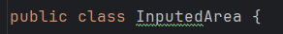
2. Declare variables: The two double variables must be declared and their names are Radius and Area.
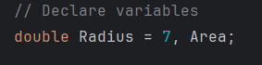
2. Applying the formula: Calculate the area by applying the formula for the area of a circle, as shown below:
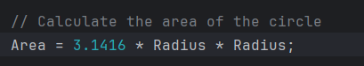

3. Printing the result: Use System.out.println() to print the area calculated.
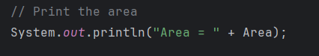
4. Compile and run the program to ensure the intended output appears.

Code:
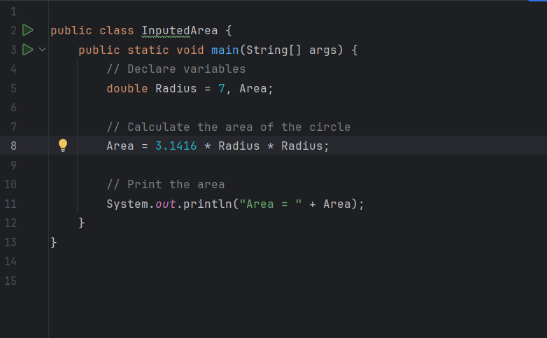

Example Input & Output:
Input: In the following program, the radius of the circle is predefined as 7.00.
Output: The program will calculate the area of the circle and print the result as:
Area = 153.9384
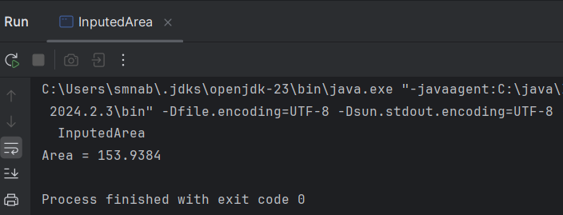
Discussion:
This program calculates and prints out the area of a circle, with a given radius. The primary purpose was to demonstrate simple mathematical operation use in Java. One refinement could be using the more precise constant Math.PI instead Pi as ‘3.1416’. This makes the calculation more accurate.
Area = Math.PI * Radius * Radius;

Conclusion:
In this lab, I learned how to calculate the area of a circle using basic Java programming techniques. The use of predefined values and then implementation of a simple formula resulted in a rather straightforward program. This lab also shows the potential for further development by the inclusion of user input and more precise mathematical constants.

